**Cambridge University Engineering Department**

IIA Projects

**Engineering Tripos Part IIA**

**PROJECTS: Interim and Final Report Coversheet**

**TO BE COMPLETED BY THE STUDENT(S)**

|  |  |  |  |
| --- | --- | --- | --- |
| Project: | SF3: Machine Learning | | |
| Title of report: | Final Report  Individual Report | | |
| Name(s): (capitals) | | crsID(s): | College(s): |
| XIAOQIAO HU | | xh297 | Trinity College |
|  | |  |  |
|  | |  |  |
|  | |  |  |
| Declaration for: Final Report  **I confirm that, except where indicated, the work contained in this report is my own original work.** | | | |

**Instructions to markers of Part IIA project reports:**

**Grading scheme**

|  |  |  |  |  |  |  |
| --- | --- | --- | --- | --- | --- | --- |
| **Grade** | A* | A | B | C | D | E |
| **Standard** | Excellent | Very Good | Good | Acceptable | Minimum acceptable for Honours | Below Honours |

Grade the reports by ticking the appropriate guideline assessment box below, and provide feedback against as many of the criteria as are applicable (or add your own). Feedback is particularly important for work graded C-E. Students should be aware that different projects and reports will require different characteristics.

|  |  |
| --- | --- |
| *Penalties for lateness:* | *Interim Reports: 3 marks per weekday; Final Reports: 0 marks awarded – late reports not accepted.* |

**Guideline assessment (tick one box)**

|  |  |  |  |  |
| --- | --- | --- | --- | --- |
| **A*/A** | **A/B** | **B/C** | **C/D** | **D/E** |
|  |  |  |  |  |

|  |  |  |  |
| --- | --- | --- | --- |
| Marker: |  | Date: |  |

**Delete (1) or (2) as appropriate (for marking in hard copy – different arrangements apply for feedback on Moodle):**

**(1) Feedback from the marker is provided on the report itself.**

**(2) Feedback from the marker is provided on second page of cover sheet.**

|  |  |  |
| --- | --- | --- |
|  | **Typical Criteria** | **Feedback comments** |
| **Project Skills, Initiative, Originality** | Appreciation of problem, and development of ideas |  |
| Competence in planning and record-keeping |
| Practical skill, theoretical work, programming |
| Evidence of originality, innovation, wider reading (with full referencing), or additional research |
| Initiative, and level of supervision required |
| **Report** | Overall planning and layout, within set page limit |  |
| Clarity of introductory overview and conclusions |
| Logical account of work, clarity in discussion of main issues |
| Technical understanding, competence and accuracy |
| Quality of language, readability, full referencing of papers and other sources |
| Clarity of figures, graphs and tables, with captions and full referencing in text |

**SF3 Machine Learning FinalReport**

Xiaoqiao Hu

xh297

1. Introduction
2. Task1: Dynamical simulation
3. Rollout simulation

In this task, different initial conditions on cart velocity and pole angular velocity are applied to the cartpole system, giving different behaviours.

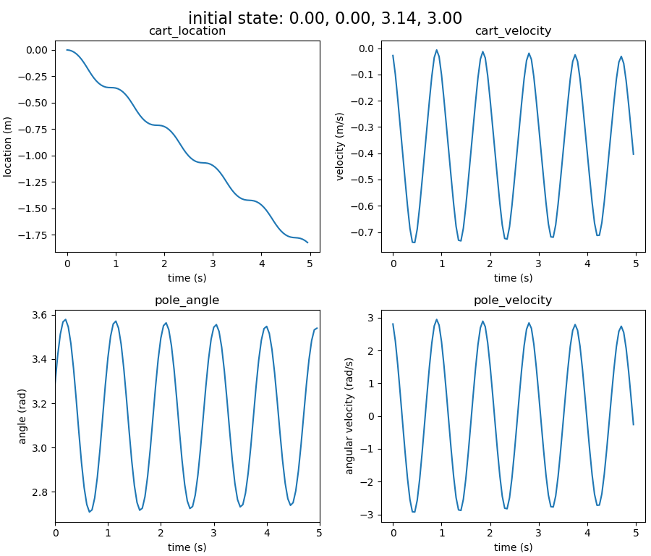 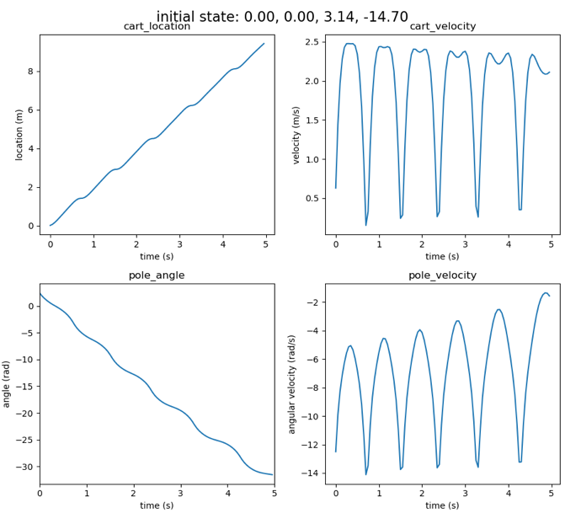

Fig 1. Time evolution of system variables

oscillation around stable equilibrium (left) and complete circular motion (right)

* Simple oscillation around the stable equilibrium given an initial state $X=[0, 0, π, 3]$, the pole angle value is oscillating around 3.14. Sinusoidal shape can be observed.
* Complete rotation of the pendulum given an initial state $X=[0, 0, π, -14.7]$, the pole angle (without remapping) monotonously decreasing as time evolves, indicating complete circular motion of the pendulum.

1. Changes of state

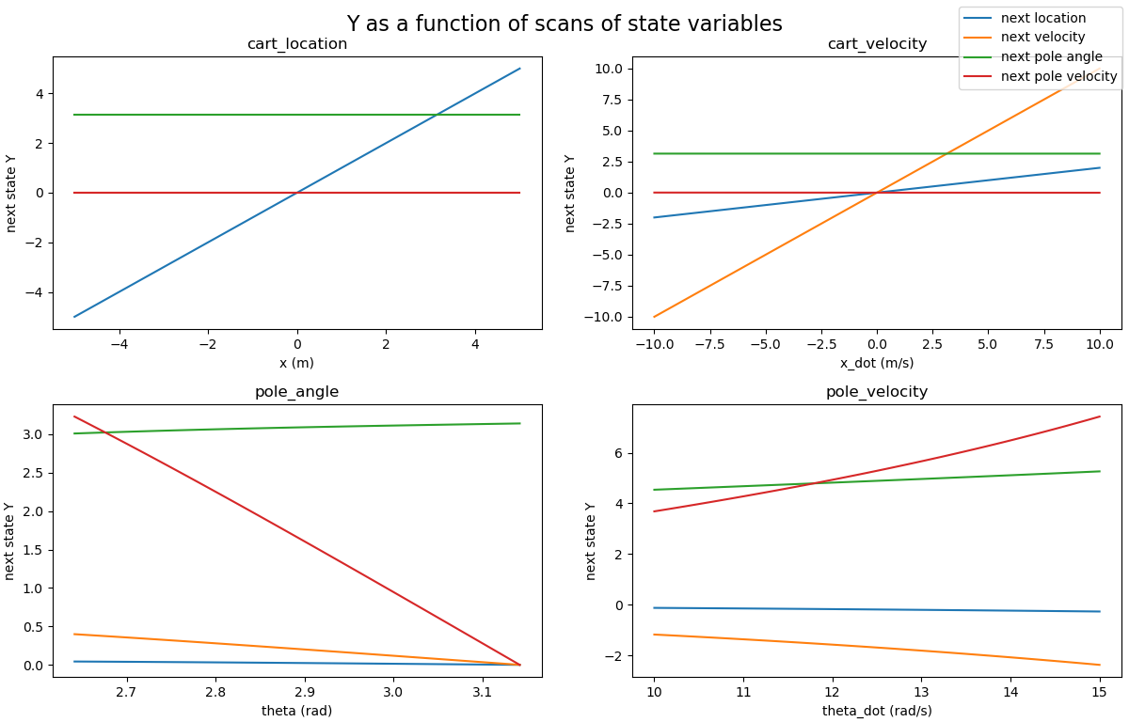

Fig 2. Next state (Y) as a function of scans of state variables

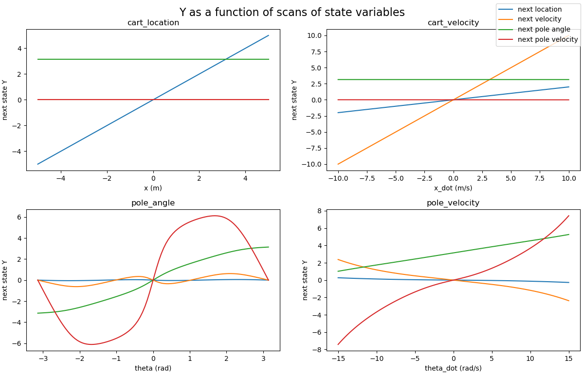

Fig 3. Next state (Y) as a function of scans of $θ$ and $\dot{θ}$ in a wider range

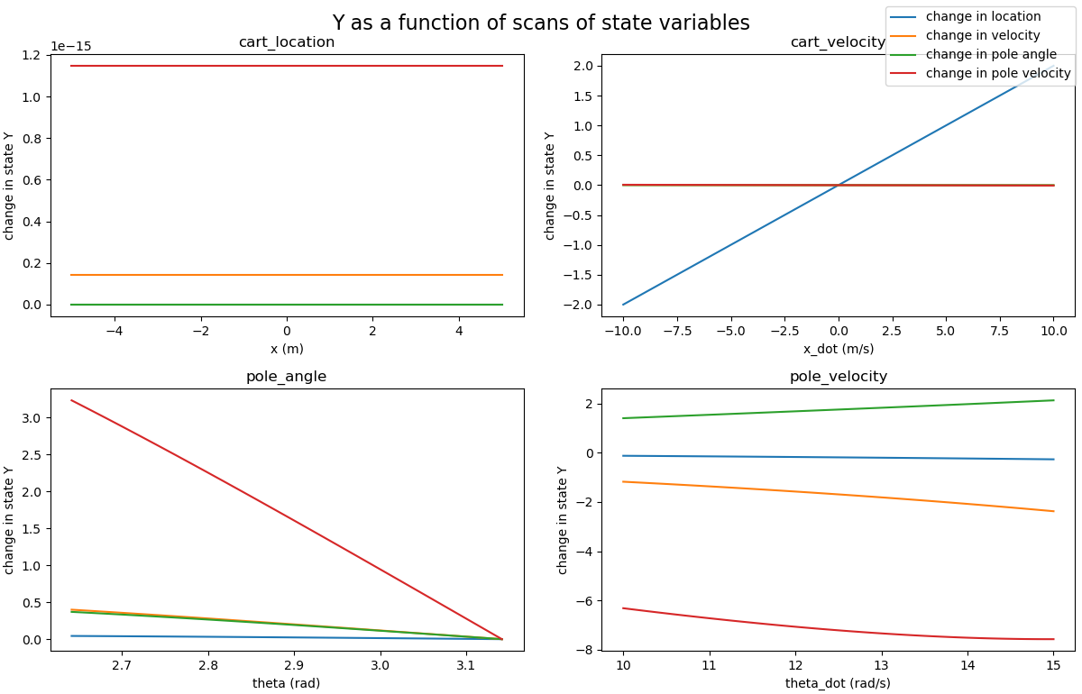

Fig 4. Change in state (Y) as a function of scans of sate variables

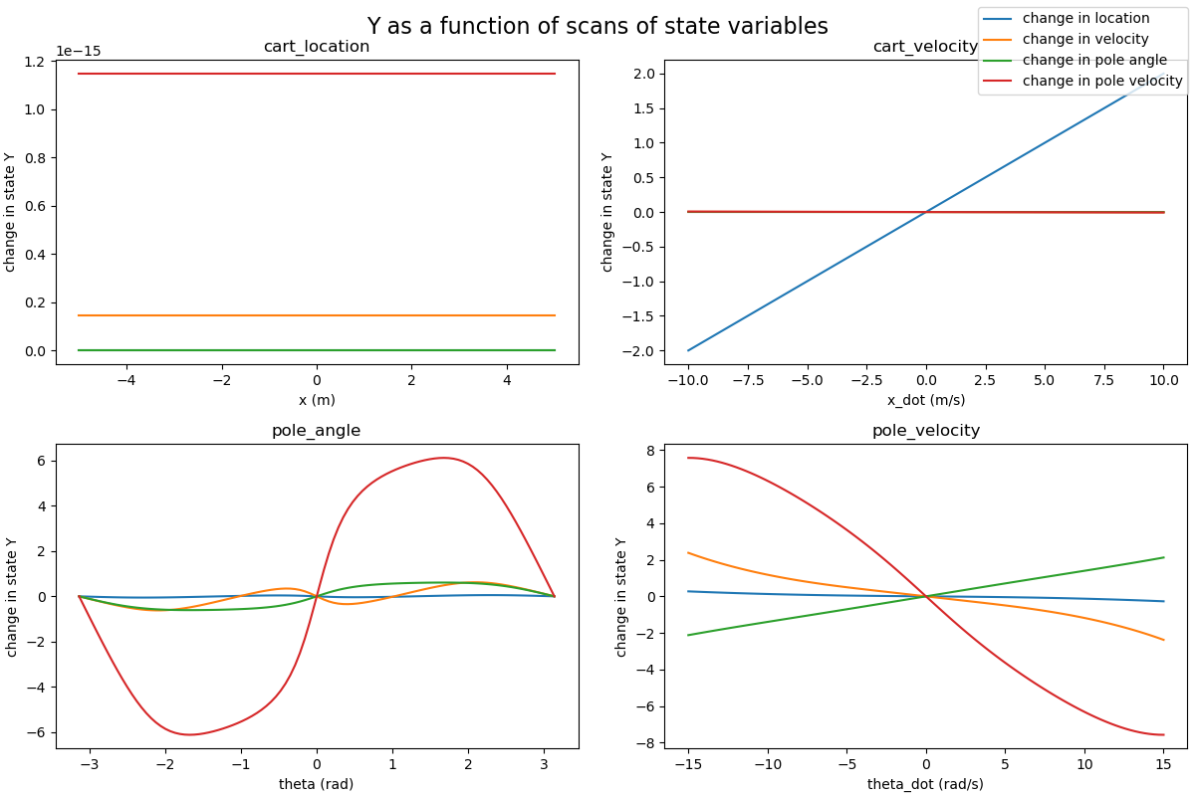

Fig 5. Change in state (Y) as a function of scans of $θ$ and $\dot{θ}$ in a wider range

* 1. Y modelled as next state

Given a random state $X$, let $Y$ be the system state after one single call to performAction function (i.e. evolving for a time step) with zero force applied. As can be observed from Fig 2, the relationship between $X$ and $Y$ can be concluded as nearly linear as the change in one step is small. It is notable that for the cart location and cart velocity, the relationship stays nearly linear irrespective of the range of the variables on the horizontal axis when other variables are held fixed. For pole angle and pole velocity, where they have a generally nonlinear relationship with the next state variables, when the range of values on the x-axis is small, linearity can be assumed. And it can be observed from Fig 3 that, in a larger scale of scans, Y does not show valid linearity (especially for next velocity and next pole velocity).

* 1. Y modelled as change in state variables

We can now consider modelling $Y$ as the change in the system state after one step: $Y≡X\left(T\right)-X(0)$, with $T$ corresponding to one single call of performAction. In this case, the plots of $Y$ as function of scans of system variables are as in Fig 4.

In this setting, the linear relationship remains as expected. Again, the linearity will not hold for some state variables on a wider scale in the pole angle and angular velocity (shown in Fig 5). In addition, from the horizontal lines in the left upper corner, it can be concluded that the cart location has no impact on the change in state variables. This can also be validated using contour plots including cart location as one of the variables, where it shows horizontal stripes when cart location is on the horizontal axis.

It is also notable that when cart velocity is one of the variables, its impact will only reflect on the change in cart location, having limited influence on the system. This is shown in Fig 7 below.

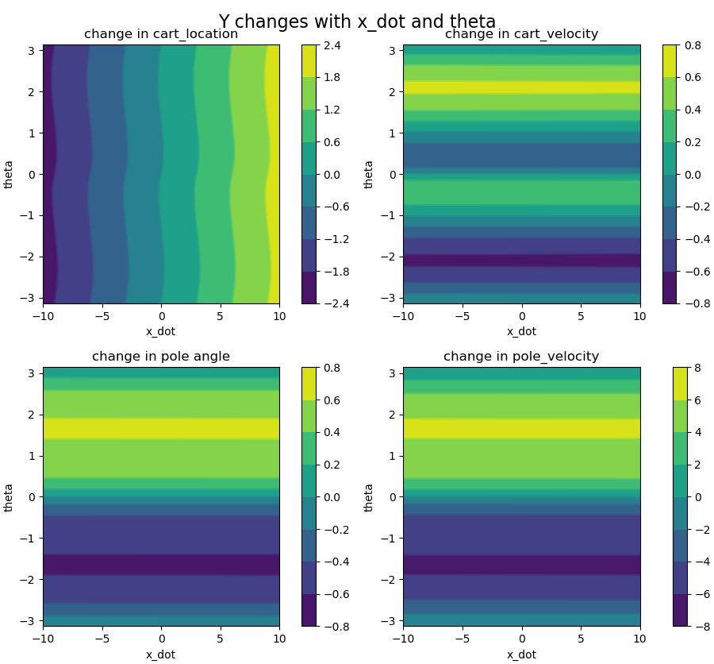 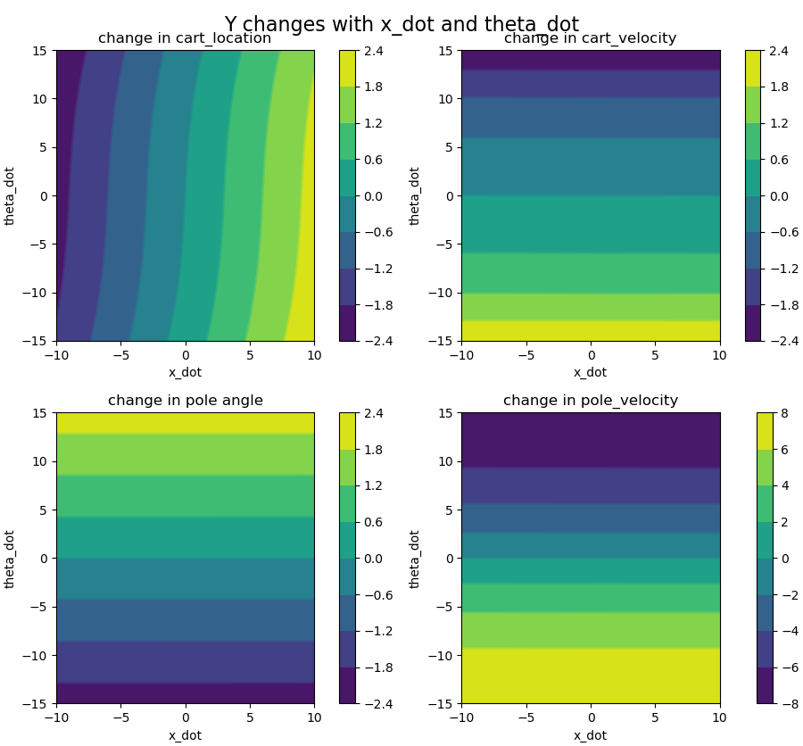

Fig 7. Contour plots of change in state Y with cart velocity as one changing variable (left: Y changes with $\dot{x}$ and $θ$, right: Y changes with $\dot{x}$ and $\dot{θ}$)

In the case of pole angle and angular velocity, relatively complicated behaviour of the system can be observed. And this is also consistent with the nonlinearity between Y and these two variables in wider scales shown in previous graphs. In smaller ranges, for example $[2.54, 3.14]$ for pole angle and $[10,15]$ for angular velocity, we can see that the stripes are nearly equally spaced, indicating the change in state can be seen as linear giving a small changing range in the state variables. The contours are shown below in Fig 8.

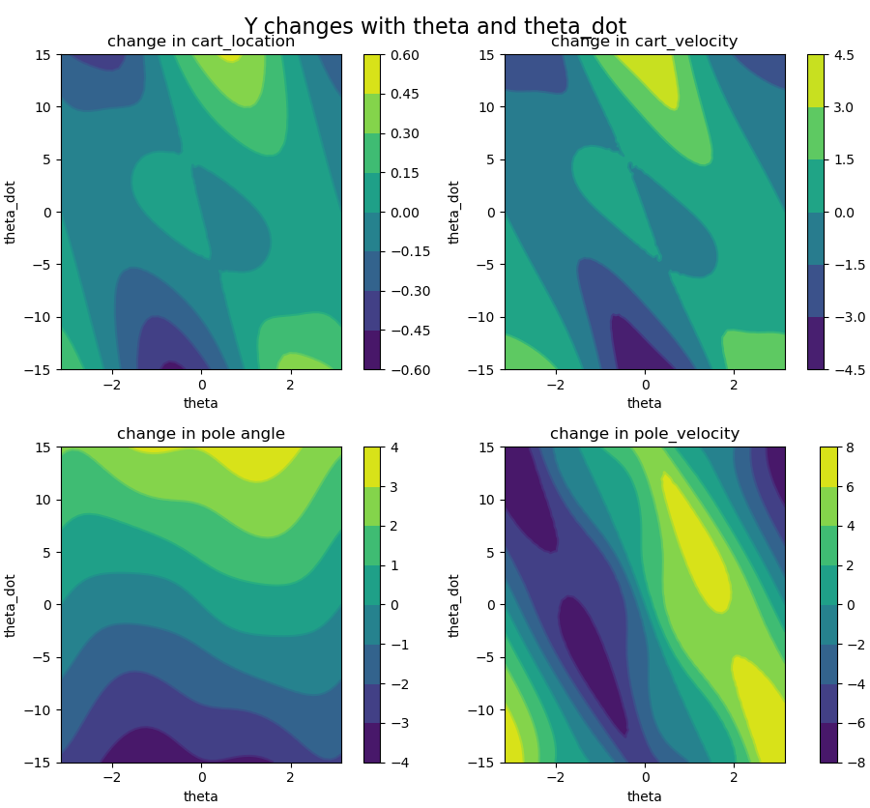 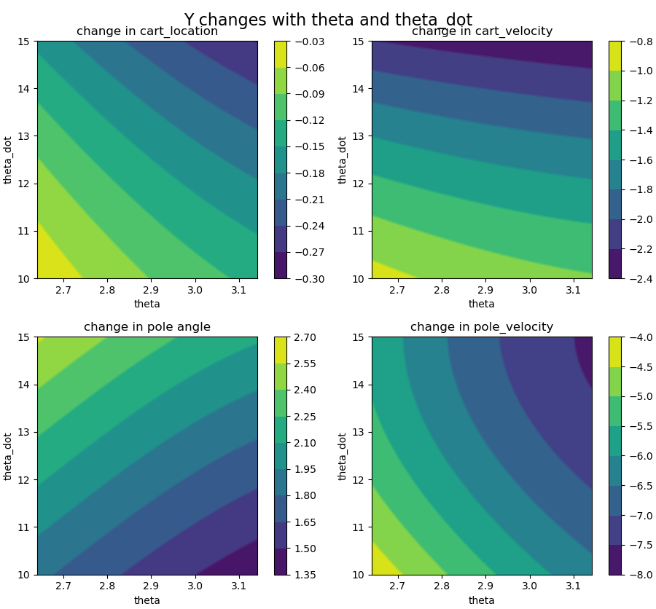

Fig 8. Contour plots of change in state Y with pole angle and pole angular velocity

From the above plots and contours we can conclude that the value in $Y$ does not change with the cart location (denoted as $x$ in the plots).

1. Linear regression

In this task, we set $X≡X(n)$, and $Y≡X\left(n+1\right)-X(n)$. We want to find the coefficients for the linear relationship $Y=f\left(X\right)=CX$. 1000 datapoints of $X$ are generated from a uniform distribution in the appropriate range of the variables and corresponding $Y$ using the relation defined. Linear regression is applied on the dataset and an optimal coefficient matrix is found to be:

$$C={\left[\begin{matrix}\begin{matrix}0.00229529 & 0.09880289 & 0.0121259 & 0.2989933 \\ 0.20218987 & 0.03619563 & 0.01620113 & 0.18313903 \\ -0.01409282 & -0.40889898 & 0.06512129 & -0.23591583 \\ 0.01132967 & 0.08200457 & 0.20283474 & -0.02881604\end{matrix}\end{matrix}\right]}^{T}$$

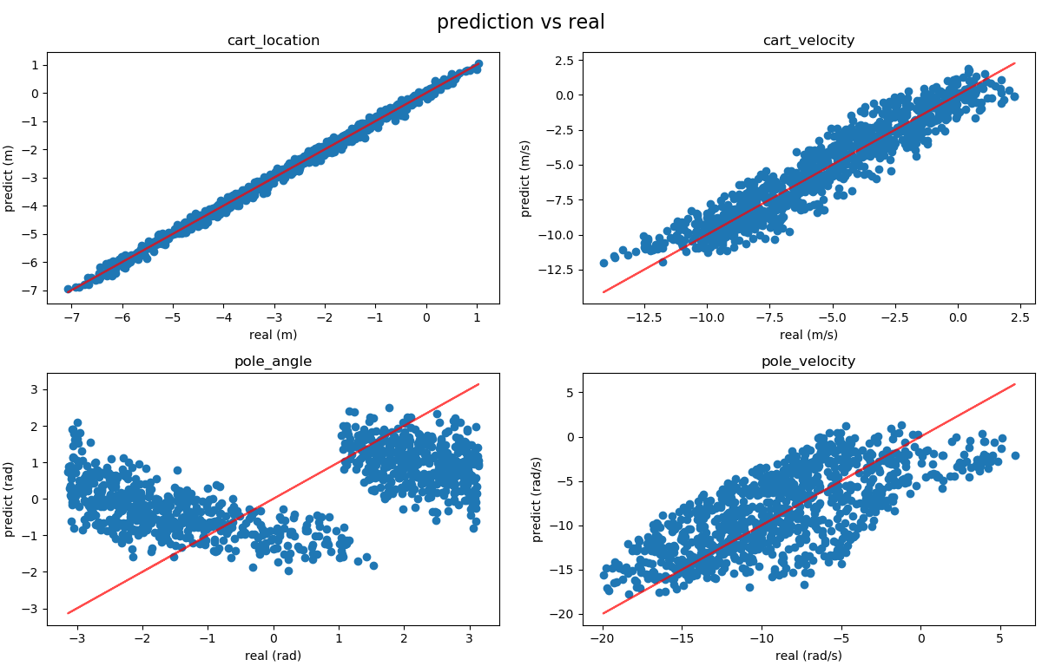

Fig 9. Linear model prediction in change of state vs real data (with the reference line in red)

To compare the model prediction result with the target, the scatter plots (model prediction as y value and real as x value) in Fig 9 are generated as above. The prediction error can be visualised as the distance of a point to the straight line in the y direction. From the plot we can see that, for the cart location, the points are centred on a straight line, indicating that the model gives good results within the limit of deviation. For the cart velocity, the points are scattered around the straight line, with relatively large errors. For pole angular velocity, the points are showing large deviations from the straight line, indicating that the model cannot give a desirable prediction. For pole angle, the points are centred in two clusters, showing poor performance in predicting.

To further elaborate, the scans of variables are used again to illustrate the model quality, as shown in Fig 10 below:

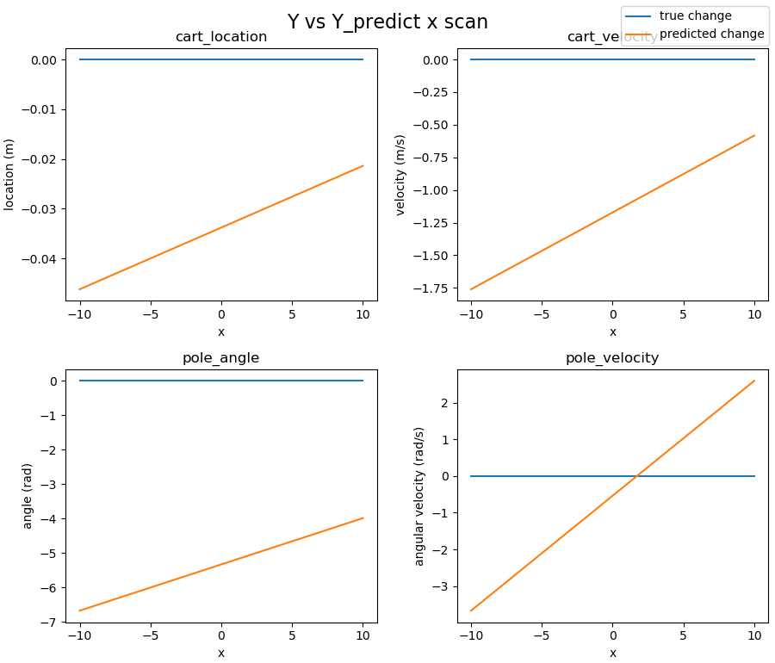 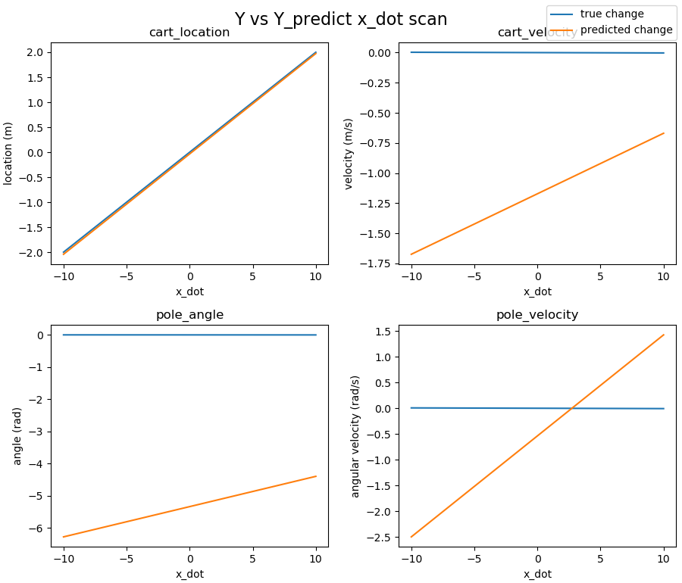

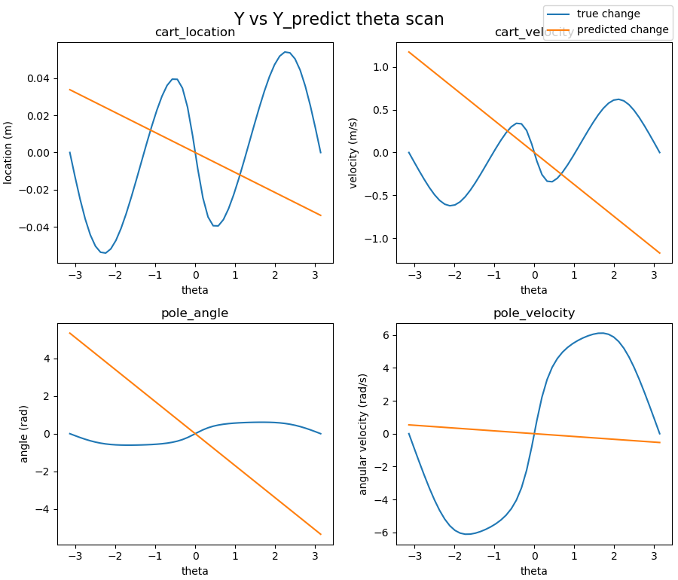 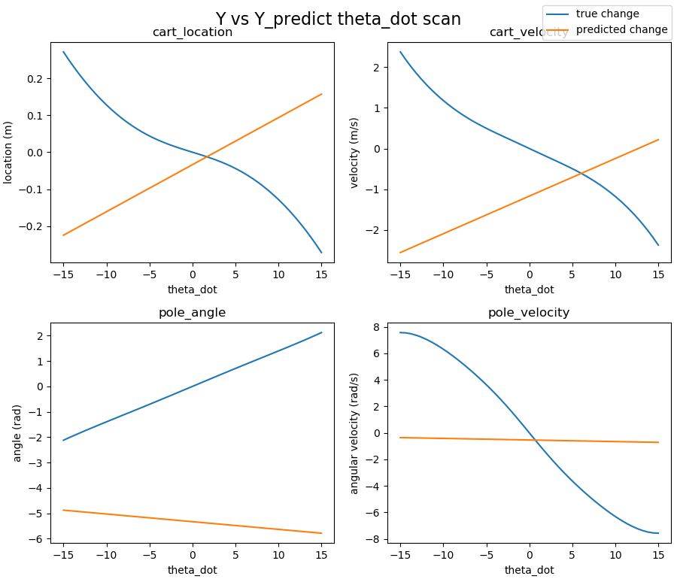

Fig 10. True value vs predicted value in change in state, varying with scans of state variables

As can be concluded from the plots above, the linear model generally will not work and will lead to enormous divergence from the real dynamics. The prediction is accurate when scanning through the cart velocity and giving the predicted change in cart location. And all the other plots show a poor fitting. This is expected since the model is trained using data generated from across the whole available range of the variables, where the data itself doesn’t show linearity in general. Although it is discussed earlier that for the cart location and cart velocity, the linearity of Y with the two variables will hold on both wide and narrow scales of ranges, the coefficients generated in linear regression minimise the overall sum of squared error (including the ones with angle and angular velocity), which will lead to large deviations in the predictions for cart location and cart velocity as well.

1. Modelling time evolution

In this task, we used the model to simulate the time evolution of the system and compared it with the true dynamics. The 2 initial conditions as described in section 1 are used. The plots are generated in Fig11 as follows:

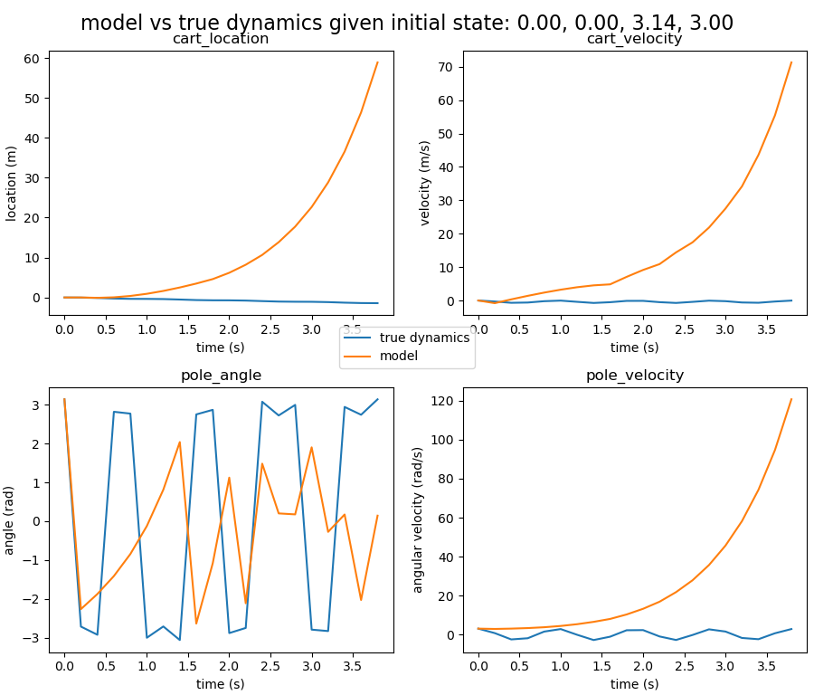 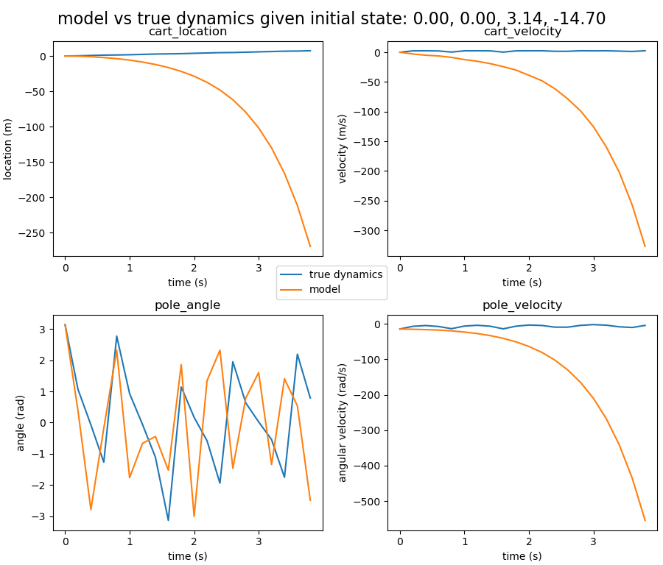

Fig 11. Time evolution modelling vs true dynamics of the system

Left: initial state of oscillation around equilibrium

Right: complete circular motion

Since simple linear model cannot deal with the periodicity in trigonometry, overall divergence shown above does not appear as surprising. In the first several time instances, the model results show relatively small deviations from the target data, and then it diverges very fast. Without remapping, the model solution with the pole angle will diverge. This is because when we fit the linear model to the data, we assume the relationship between the pole angle and Y is linear and non-periodic (Y being the change in the state variables after a single time step). In that case, the value of the pole angle in the time evolution will keep accumulating since the value of Y is adding up to get the system state at a given time instance.

1. Task2: Nonlinear model and linear control
2. Nonlinear model

To build a nonlinear model, a Gaussian kernel is applied to the dataset for each variable. Number of datapoints $N=1000$, and basis functions $M=640$ are selected, with data noise level $λ={10}^{-4}$. With the target still being the change in the system state after one time step, the results of fitting are shown in the scatterplot in Fig12.

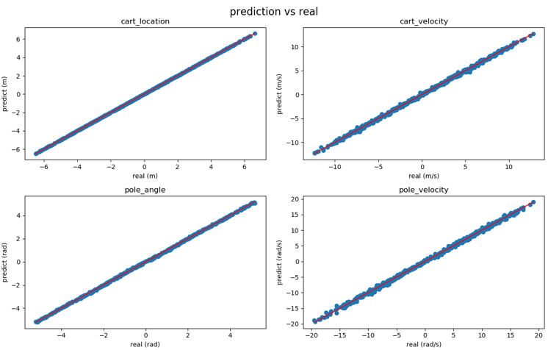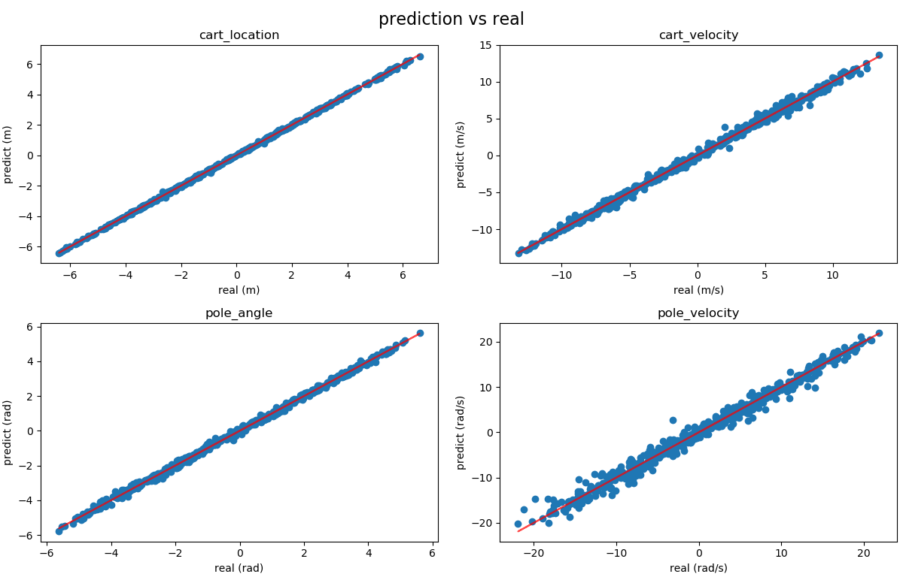

Fig12. Nonlinear model prediction in change of state vs real data (left: with state variables being the same as before, right: system state includes the action taken as the fifth variable)

As can be observed from the left part of Fig12, the scatter points overlap with the reference straight line, showing a satisfactory fitting result.

The convergence of the model can be studied by looking at the systematic reduction in error as a function of data amount (N) and the number of basis functions (M). Mean squared error (MSE) is used in this case. Fig 13 shows the change in MSE with increasing data amount N where we keep M=10 and the change in MSE with increasing M with N = 1000 unchanged. From the plot we can see that as data amount grows the mean squared error of prediction also increases. This is expected since the linear functions are over-determined and more datapoints will give rise to a larger accumulation of errors. And the MSE will drop as we increase the number of basis functions, whose locations are selected randomly from the datapoints. Thus, for training the model, N = 1000 and M=640 are used for a better fitting.

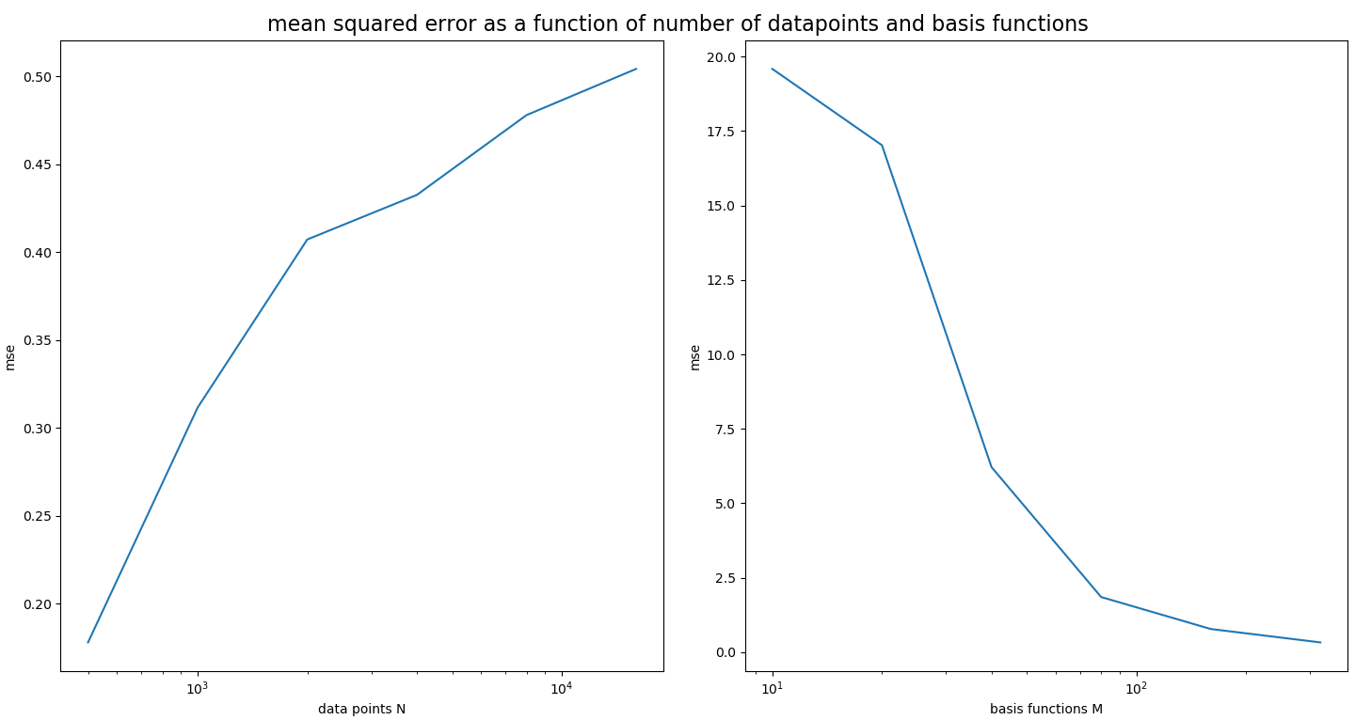

Fig 13. Mean squared error as a function of data amount and number of basis functions

And the scans of state variables can again be used to illustrate the model quality, shown in Fig 14.

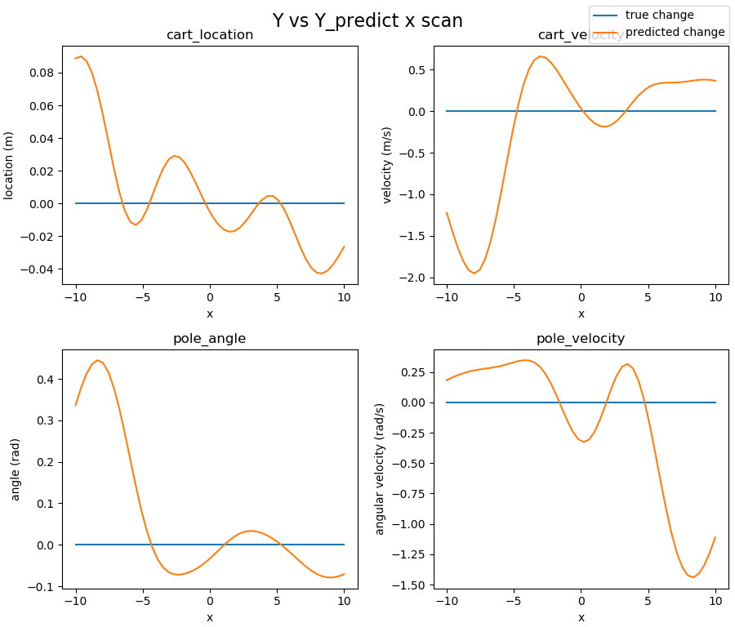 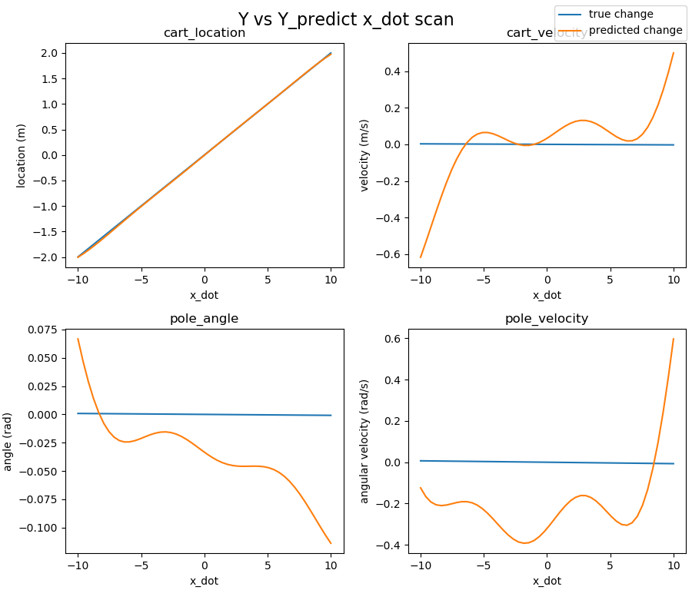

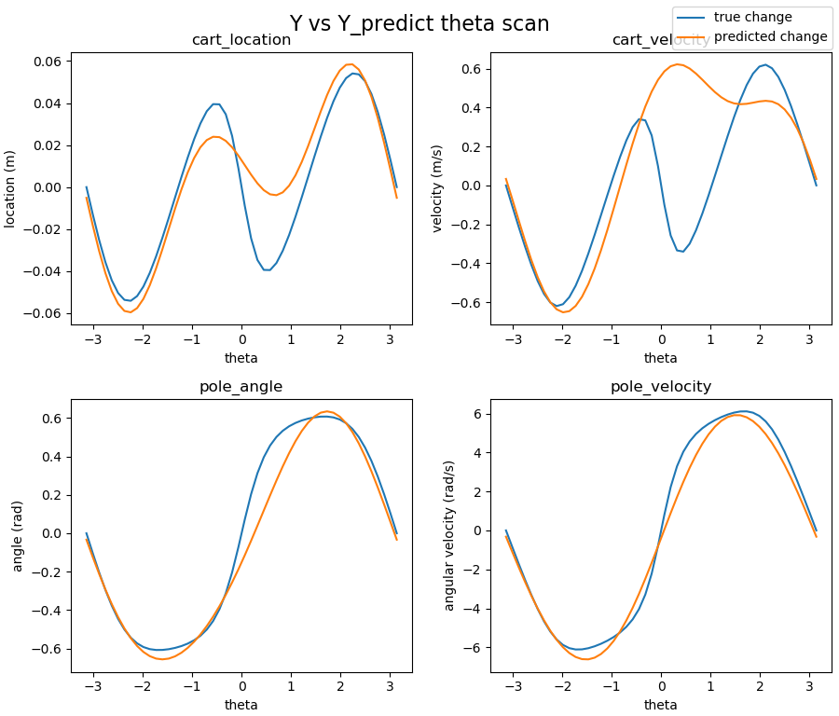 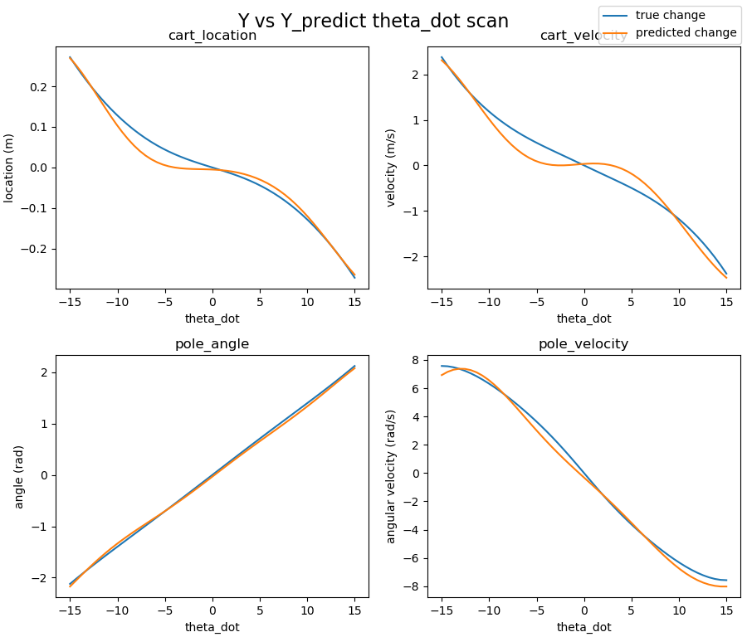

Fig 14. True value vs predicted value in change in state, varying with scans of state variables

As we can observe from the scan for $θ$ and $\dot{θ}$, the nonlinear model shows great improvement on predicting the change in state, compared to the linear model in Fig 10.

The rollouts for 2 different initial conditions as in previous sections are shown in Fig13.

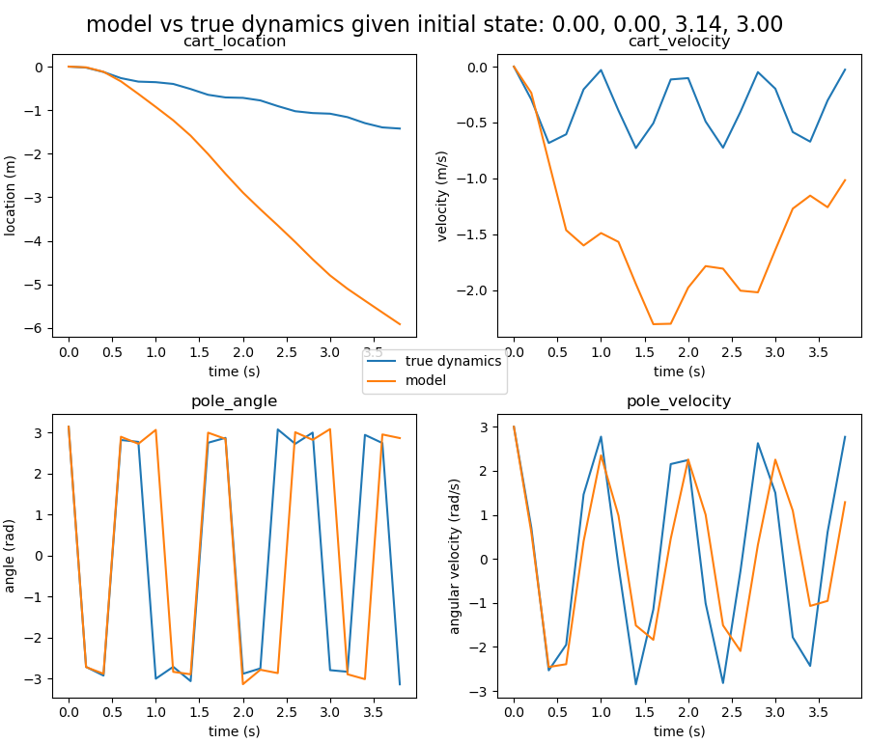 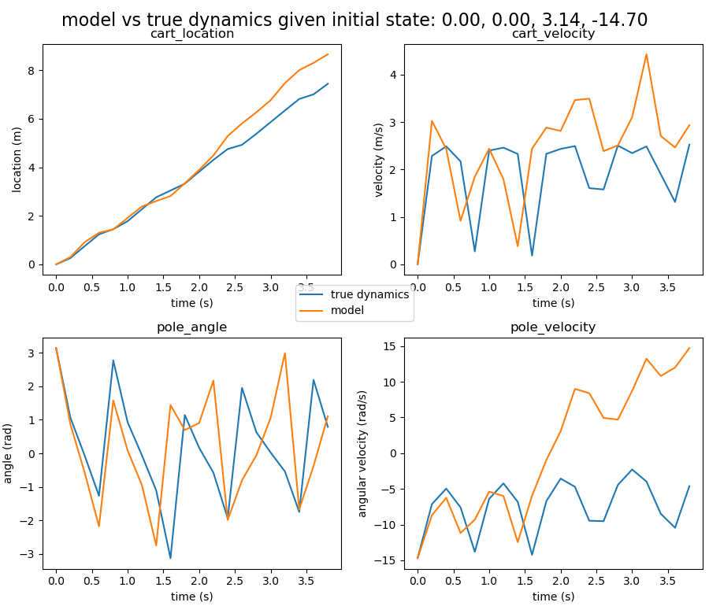

Fig 13. Time evolution modelling vs true dynamics of the system

Left: initial state of oscillation around equilibrium

Right: complete circular motion

Within the limit of deviation, we can conclude that within the first 1.0-1.5 seconds (5-8 time steps and around 2 oscillation cycles) the nonlinear model shows reasonable agreement with the real dynamics. Taking into consideration the pointwise error, which will accumulate over time, the model will have increasing deviations from the real dynamics.

1. Control

With newly collected data, we now include the action taken into the state vector. The scatterplot of the fitting result is shown in the right-hand side of Fig12. The model still shows reasonable agreement with the real data, with a larger deviation in the pole velocity.

Again, scans of state variables are used to verify that the model still works, shown in Fig 15.

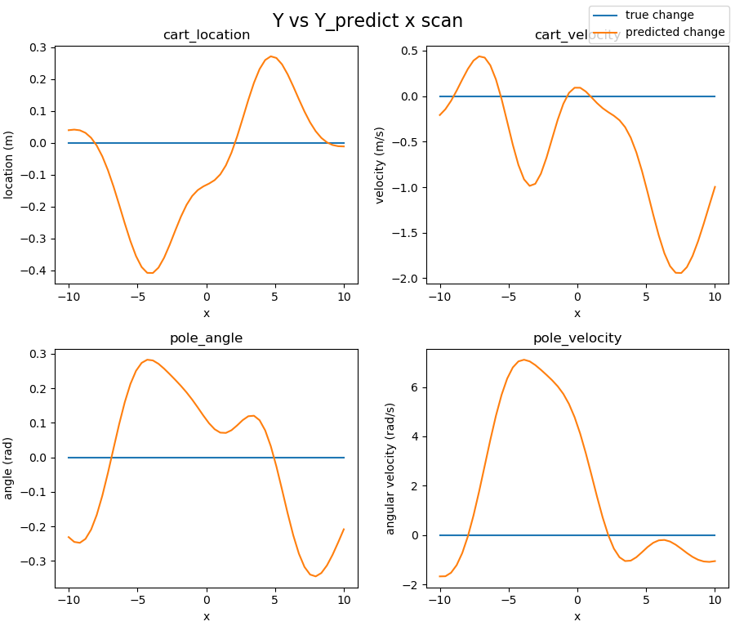 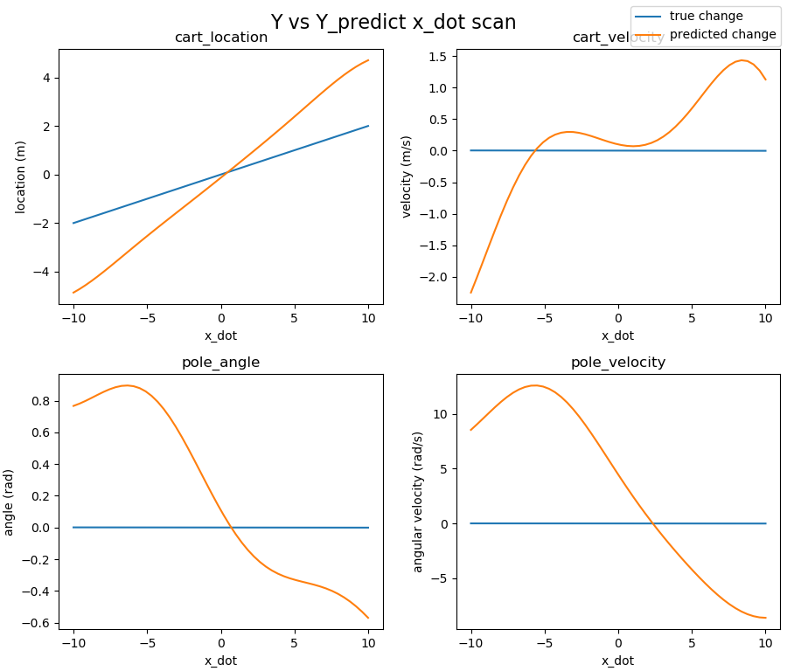

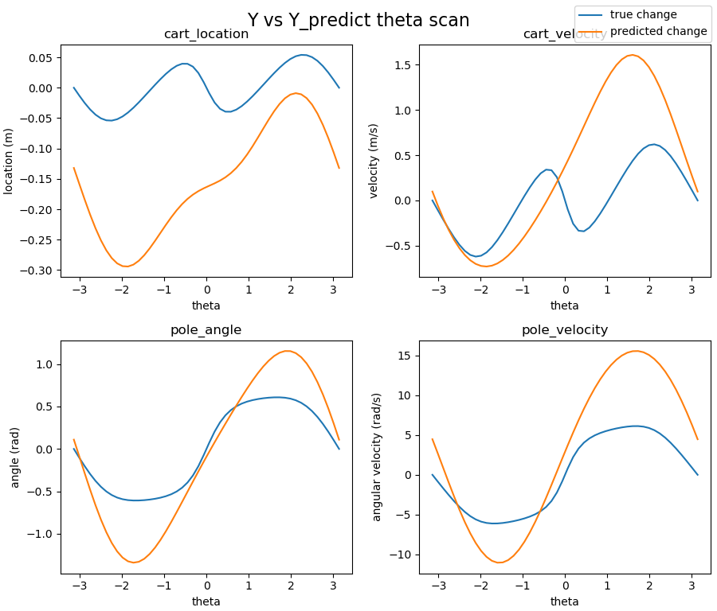 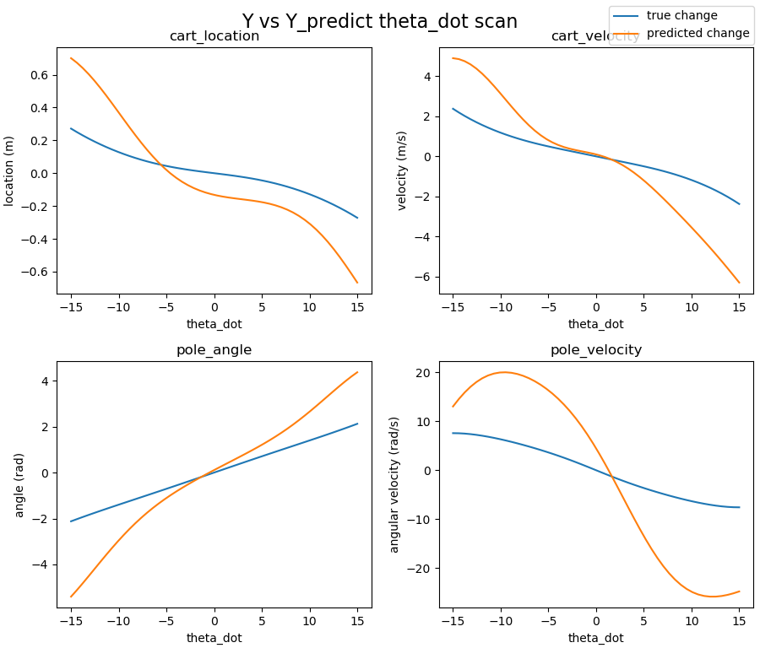

Fig 14. True value vs predicted value in change in state, varying with scans of state variables

The rollouts using the same initial conditions are shown in Fig14, where the model still gives reasonably good prediction within the time limit of 1.5s.

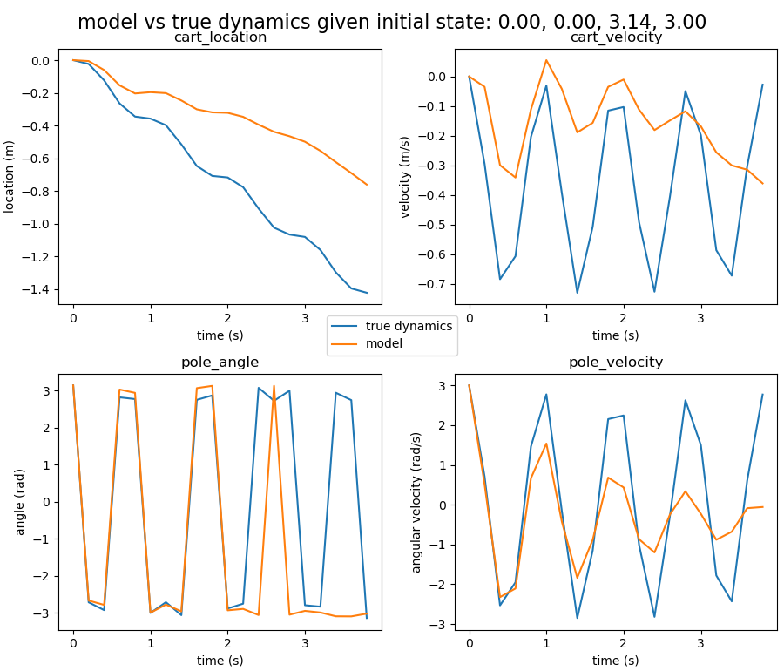 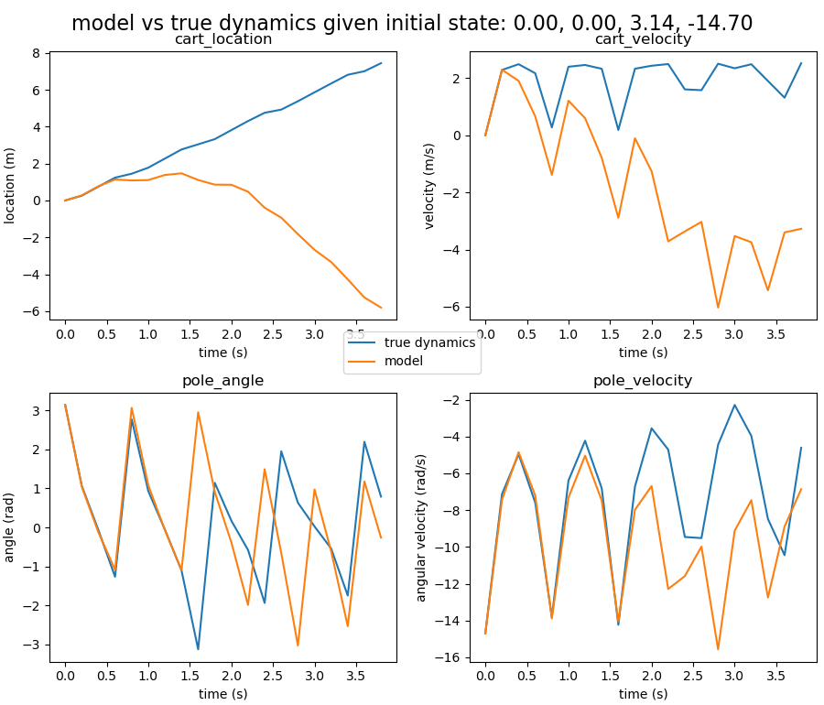

Fig 14. Time evolution modelling vs true dynamics of the system

Left: initial state of oscillation around equilibrium

Right: complete circular motion

1. Policy and linear control

In this task, functions to evaluate system loss in 10 seconds of the rollout are written. Considering the real scenario where we want to keep the pole upright, an initial state of the system $[0, 0, 0.3, 0]$ is chosen. With an initial value for $p$ being $p=[0, 0, 0, 0]$ (no action taken in each step), the loss value against 1D scans of variables in $p$ are shown in Fig15. We can observe that the Loss decreased for elements of p in a smaller range of values, where we can zoom in to plot 2D contours with 2 elements of p changing, shown in Fig16.

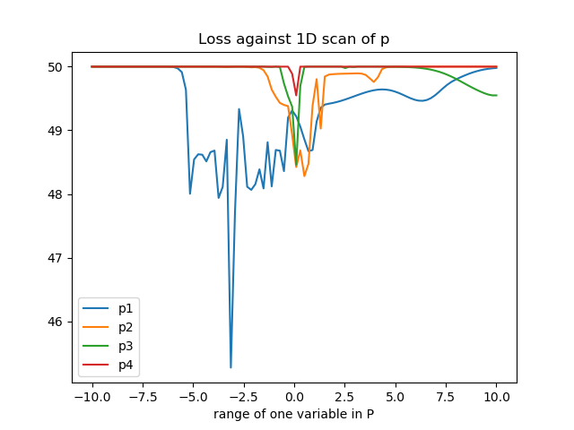

Fig 15. Loss against 1D scans of variables in p

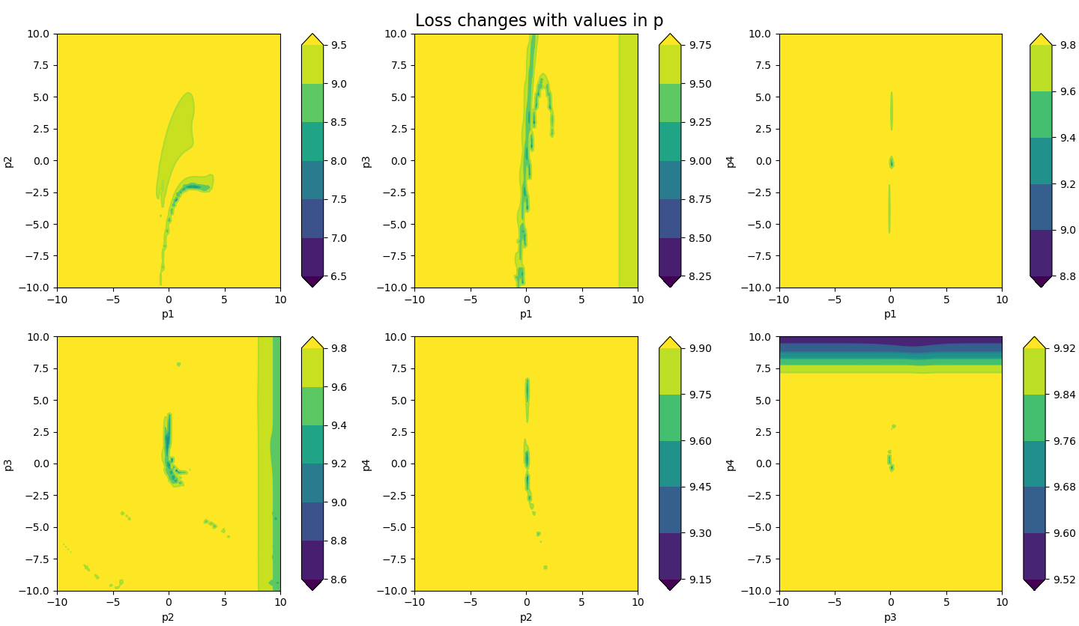

Fig 16. Loss against 2D scans of variables in p

Then, the value of $p$ is optimised using the Nelder-Mead method.

From both the 1D and 2D plots, we can start optimising $p$ from $p=[0, 0, 0, 10]$. Optimising $p$ against the total loss of the system in 15 seconds of rollout starting from $[0, 0, 0.3, 0]$, we get a value of $p$, where the system will stabilise in 5 seconds and diverge in a longer timeframe. And take somewhere near this value as a starting point ( $[-4, 10, 19, 5]$ in this case), optimise again. The value $p$ that can stabilise the system is then obtained ($p=[0.95, 0.85, 17.14, 2.44]$). For small angles up to $0.7$, system stability can be achieved. The rollout of the system with policy $p$ is shown in Fig 17.

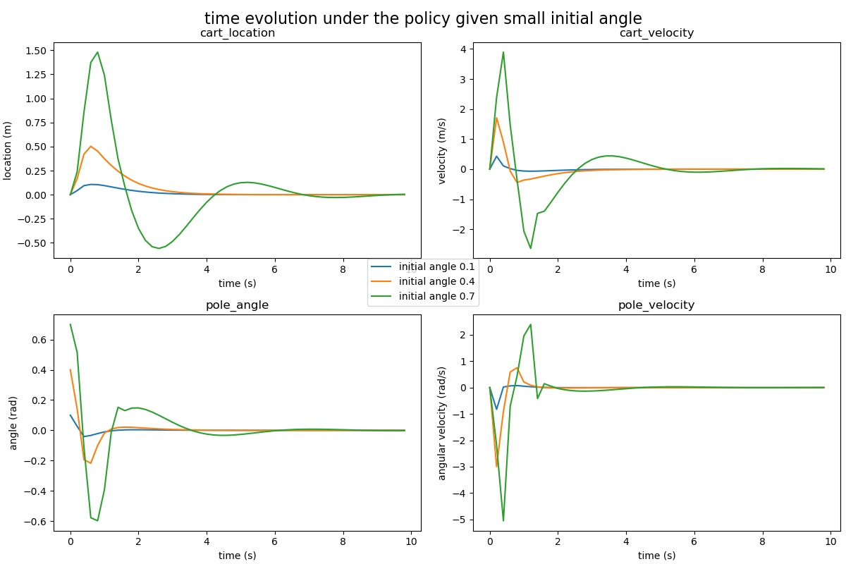

Fig 17. Time evolution under the optimal linear policy

1. Model predictive control

In this task we use the model to evaluate the loss and optimise the policy. Due to unavoidable error in the model compared to the true dynamics, slightly different $p$ values are obtained. After trying different starting point for optimisation, stabilisation is also achieved when testing in the real system. It is obtained that $p=[0.77, 1.59, 20.12, 2.59]$. However, the first several seconds of the model give a bumpier reaction, and the maximum starting angle to achieve stability decreases to $0.5$, compared to $0.7$ in the last section. The time evolution of system is shown in Fig 18.

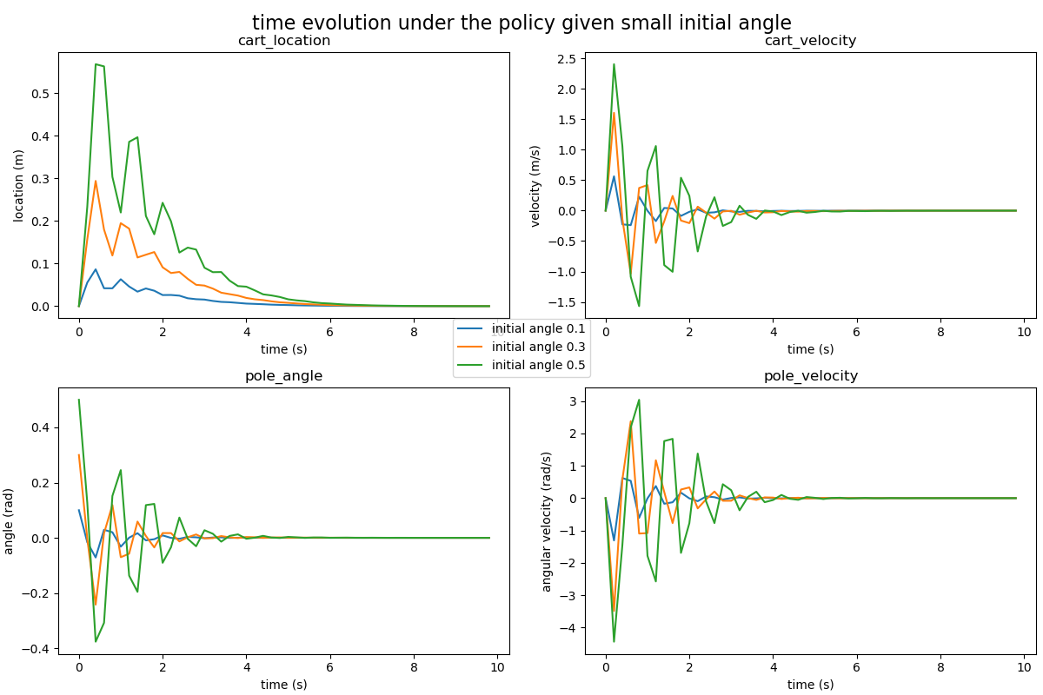

Fig 18. Time evolution under the optimal linear policy

1. Task3: Sensitivity and stability
2. Noise in observed dynamics

In this task we introduce noise in the observed dynamics and refit both linear and nonlinear models. This is to simulate the errors in observations caused by sensors etc. In generating the dataset, Gaussian noises with mean 0 and standard deviation 0.1 are randomly generated and added to each of the state variables. We pass the noiseless version of current state into the dynamic system and get the next state. Add noise to the next state and subtract from it the noisy current state to get the change in state Y (observed change in state). Comparisons are made in the following dimensions: pointwise accuracy in prediction (using mean squared error); time evolution in a rollout.

1. For the linear model, the mean squared error for 4 different levels of noise is explored, shown in Fig 19. As we can see from the plot, there is divergence with small data amount N, but they all converge when N is large enough. This means that when we have enough datapoints, the effect of observation noise can be countered. A model is trained with N = 1000 datapoints. And the rollout with initial condition $[0, 0, π, 3]$ is shown in Fig 19. The error will accumulate with time, so observation noise generally leads to a poorer model as we can see the divergence in cart velocity and pole velocity is faster than the noise-free model.

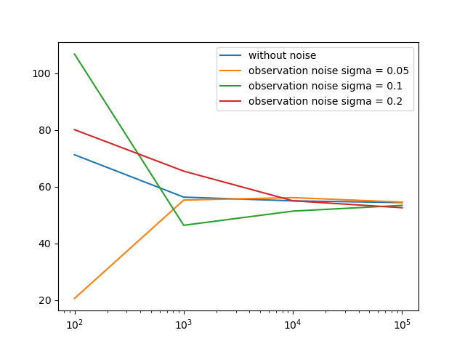

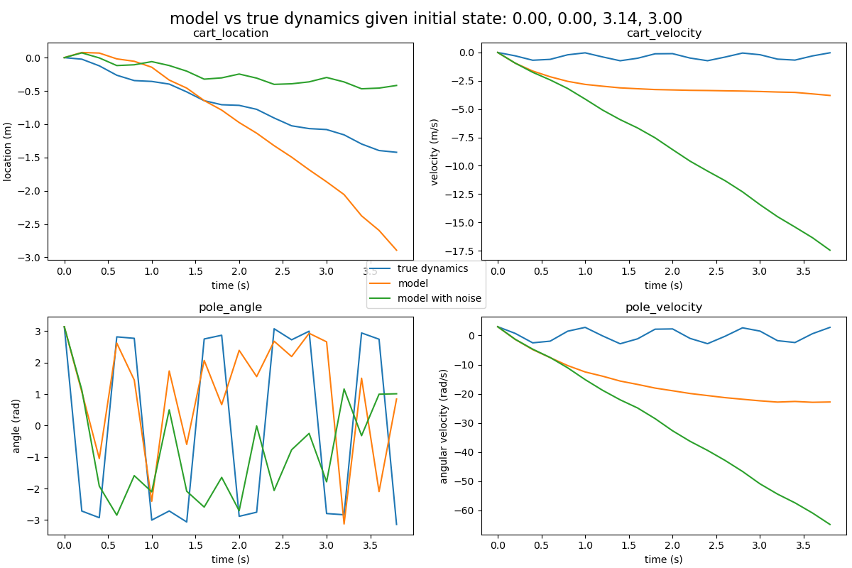

Fig 19. Rollout with linear model (with/without observation noise)

1. For the nonlinear model, using the same methods, the plots are obtained.

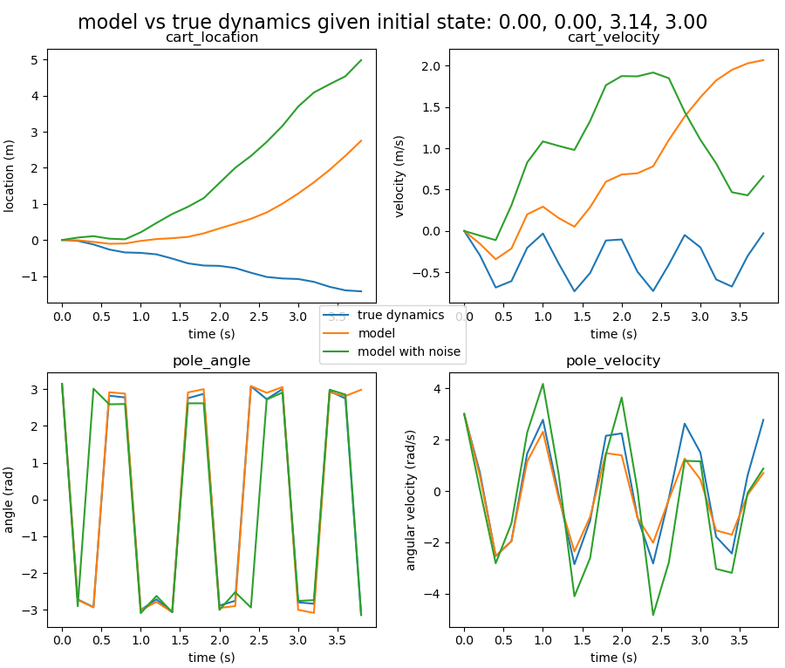

Fig 20. Rollout with nonlinear model (with/without observation noise)

Similar conclusions can be drawn as those in linear model case.

1. For the linear policy, the effect of observation noise is mainly in the calculation of loss (since we make inaccurate observations of system states), and if we use the model to optimise $p$, the degradation in prediction accuracy will have larger impact on the calculation of loss. This is consistent with the experiment result: starting from the same positions in the noise-free cases, the $p$ value obtained using true dynamics can still stabilise the system in presence of noise; however, the $p$ value obtained using the model failed to stabilise the system. After trying a few other starting points, the stabilisation can be achieved with

It can be concluded that the observation noise can be largely compensated by increasing the number of datapoints used to generate the models.

1. Noise in actual dynamics

In this task we assume that all observations are accurate, but there are noises in the dynamic system. When generating the dataset, a Gaussian noise is added to the action term in every call of performAction.

In this case, we can conclude that the models generally don’t give very good prediction and control.

1. Task4: Nonlinear control

For the linear policy, the effect of observation noise is mainly in the calculation of loss (since we make inaccurate observations of system states), and if we use the model to optimise $p$, the degradation in prediction accuracy will have an even larger impact on the calculation of loss.

1. Conclusion

In the first part of this project, we observed and analysed the local linearity of the inverted pendulum system when there is a small deviation from a given state. However, it is not adequate to apply a simple linear model to the wider scans of the variables since linearity only holds in small segments. And when simulating the dynamics, in the time evolution, the error will accumulate over the process, which leads to a large divergence of the model output, as can be observed. It can be concluded that the linear regression model, in general, cannot work well for an inverted pendulum system. To improve the results, nonlinear modelling is required, which will be explored in the next stage.

1. Appendix

All codes used for the dynamical simulation and plotting are included, also available at Deepnote.

















